Record No: 0666
ALAN EVERARD WHICHNOR BELLINGHAM SOMERVILLE (Alan)

3rd son of Bellingham Arthur Somerville (0631) by his wife Margaret Hall Clinch (0632).

Birth: 6 Oct 1885, at Merville, Queenstown, Co Cork
Bapt: 8 Aug 1886, at St Audoen’s Dublin
Death: 14 Dec 1887, at Merville, Queenstown Co Cork
Burial: 19 Dec 1887, in Wicklow churchyard

Source: Somerville Index

Notes:
It seems strange at first sight that Alan should have died in Queenstown and been buried in Wicklow with which his parents up to then had no connection. BAS’ Office Journal inter alia shows as follows:
“ Wednesday 16th November 1887 till Saturday 19th November. On leave of absence in Dublin and Wicklow”
“ Friday 2nd December 1887. At office all day finishing up accounts as I have been transferred at my own request from the 1st to Wicklow.
Saturday 3rd December 1887. At office. Left Queenstown at 11.30 on transfer to Wicklow. Missed the last train from Dublin to Wicklow”
He then spent the next 11 days, at Wicklow, at the office, drilling, parading and attending the Assize Court. On 14th December he went on leave until 14th January 1888 – for one month – presumably compassionate leave, resuming charge of the District on 15th January. During this period, it is reasonable to assume that the family moved to Wicklow and Alan was buried there.

Source: WBRBS from BAS’ office Journal

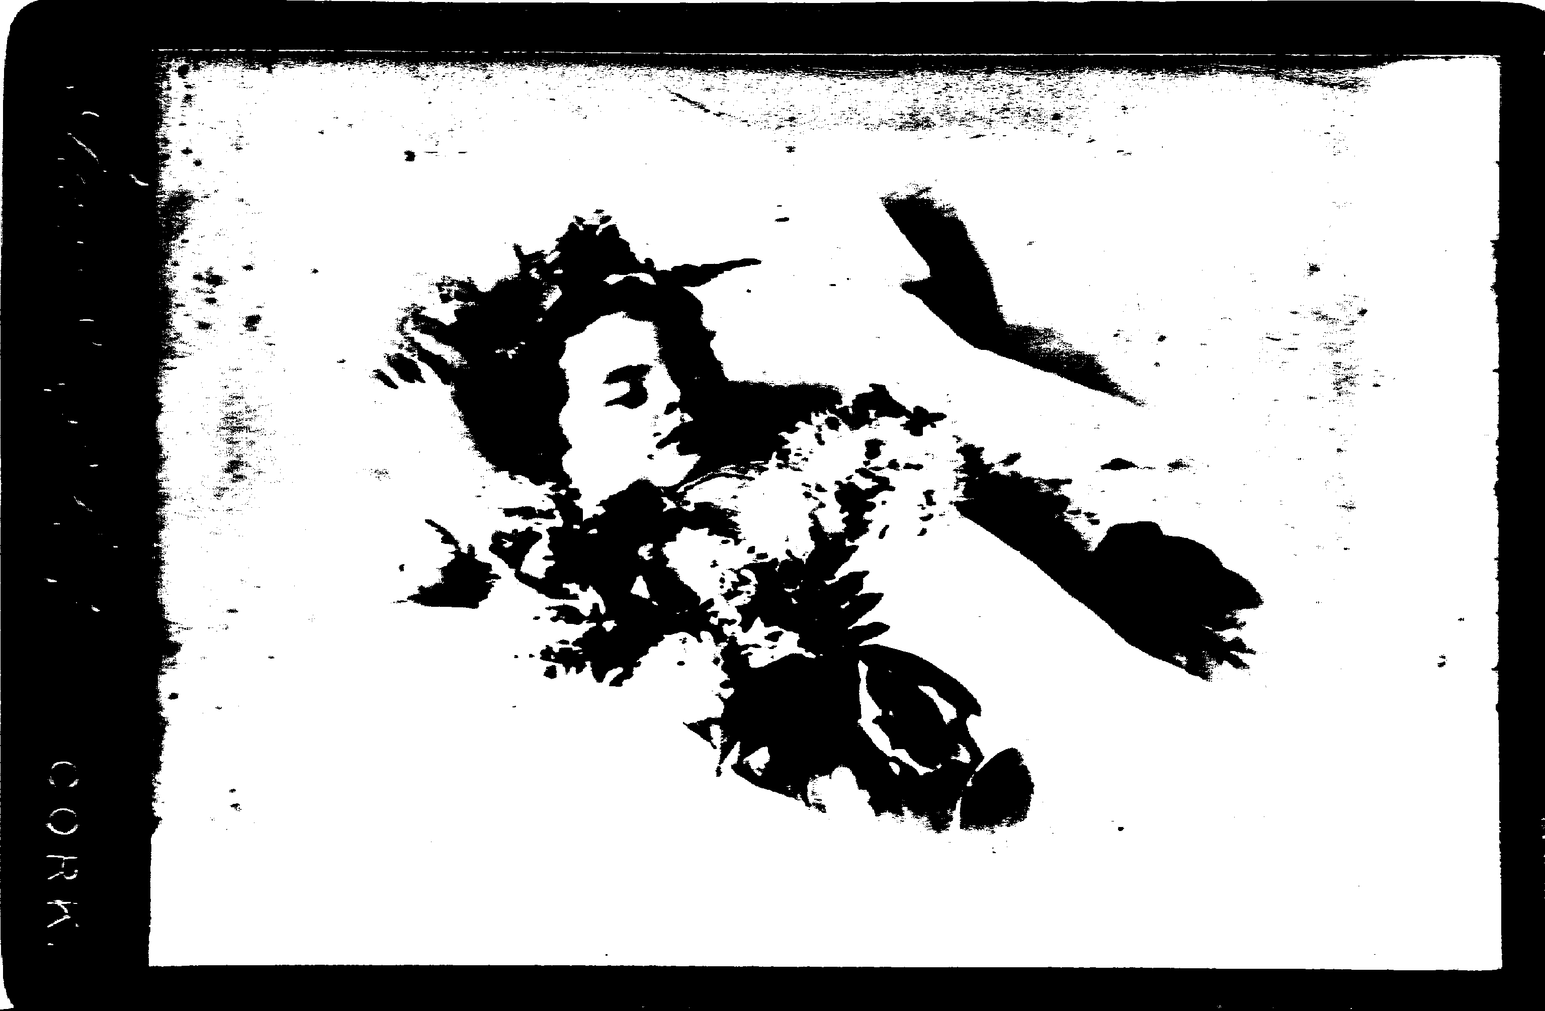
Alan on his deathbed 1887

